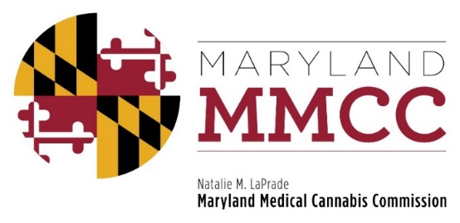
Policy Committee Meeting
Monday, June 25, 2018: 1:30 PM
Winchester Hall
12 E. Church St., Frederick, MD 21701
AGENDA

- Call to Order and Welcome
Commissioner J. Charles Smith, Policy Committee Chairman

- Approval of the April 16, 2018 Meeting Minutes

- Discipline and Enforcement – Summary Suspension: COMAR 10.62.34.05
- Presentation by Will Tilburg, Director of Policy & Government Relations
- Discussion
- Independent Testing Laboratory – Transport of Medical Cannabis Samples: COMAR 10.62.16
- Presentation by Will Tilburg, Director of Policy & Government Relations
- Discussion
- Change of Ownership of License: COMAR 10.62.08, 10.62.19, 10.62.25
- Presentation by Will Tilburg, Director of Policy & Government Relations
- Public Comment
- Discussion
- Advertising: COMAR 10.62.36
- Introduction by Will Tilburg, Director of Policy & Government Relations
- Public Comment
- Discussion
- Grant Funding for Patient Outcomes
- Introduction by Will Tilburg, Director of Policy & Government Relations
- Public Comment
- Discussion
- New Business
- Adjournment

