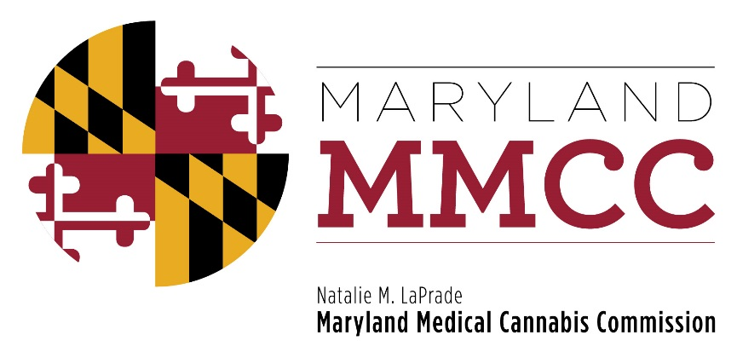
Maryland Medical Cannabis Commission
Committee Meeting
Thursday, September 27, 2018
2:00 pm
Annapolis City Council Chambers
160 Duke of Gloucester Street, Annapolis, MD 21401
AGENDA

- Call to Order and Welcome
Commissioner Brian Lopez, Chairman
- Executive Director’s Report: Joy A. Strand, MHA
- Committee and Subcommittee Reports:
- Final Review Subcommittee: Voting on Licenses & Registration
Commissioner Nancy Rosen-Cohen, PhD, Chair
- Policy Committee:
Commissioner Chairman Charles Smith, Esquire, Chair
Presentation by Will Tilburg, Director of Policy & Government Relations
- Introduction of Special Guests: John Fitzgerald, Chief, Chevy Chase Village Police Department and Phillip E. Hinkle, Chief of Staff, Charles County Sheriff’s Office

- Closed Session to Receive Legal Advice
- Return to Open Session
- Commission Vote: Draft Regulations
- Report on House Bill 2 provisions and MMCC Grants for Medical Cannabis Educational & Business Development Training Program
Will Tilburg, Director of Policy & Government Relations
- New Business

- Next Full Commission Meeting – December 6, 2018
- Adjournment

