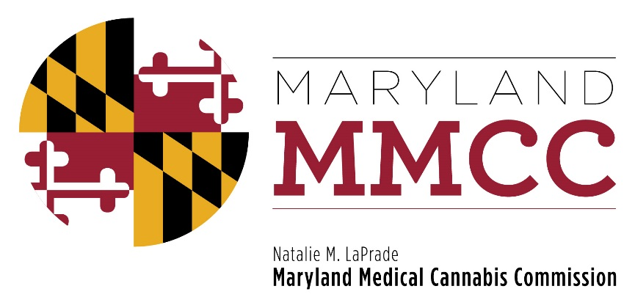
Maryland Medical Cannabis Commission
Committee Meeting
Tuesday, May 21, 2019
4:00 pm
Conducted Via Conference Call
AGENDA
- Call to Order and Welcome
- Executive Director’s Report: Joy A. Strand, MHA
- Committee Reports
- Executive Committee
- Research Committee
- Education & Outreach
- Policy Committee
- Finance & Budget
- Final Review Subcommittee Report
  - Vote on Dispensary Licenses
  - Vote on Extensions of Operational Deadline
  - Vote on Extension for ISO 17025 Accreditation
  - Vote on Compensation Agreements

- Legislative Update: Will Tilburg, Director of Policy & Government Affairs
- Regulatory Update: Will Tilburg, Director of Policy & Government Affairs
- New Business
- Next Full Commission Meeting: June 27, 2019-2:00 pm
Joint Hearing Room, Department of Legislative Services Building,
90 State Circle, 1st Floor, Annapolis, MD 21401

- Closed Session to Receive Legal Advice
- Adjournment

