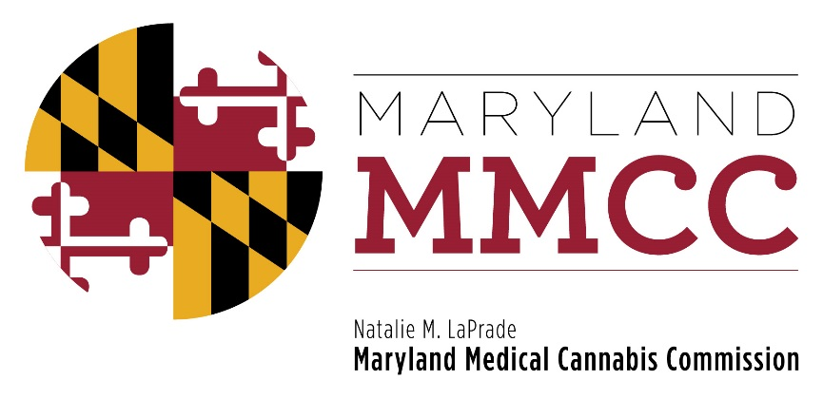
Maryland Medical Cannabis Commission

AGENDA
Monday, June 26, 2017
Conducted by Conference Call

A PORTION OF THE MEETING MAY BE CONDUCTED
IN CLOSED SESSION

AGENDA

- Call to Order

- Approval of Minutes of November 28. 2016 and May 17, 2017 Meeting Minutes

- Closed Session to Receive Legal Advice and Discuss Pending Litigation

- Committee Report: Final Review Subcommittee

- New Business

- Adjournment

