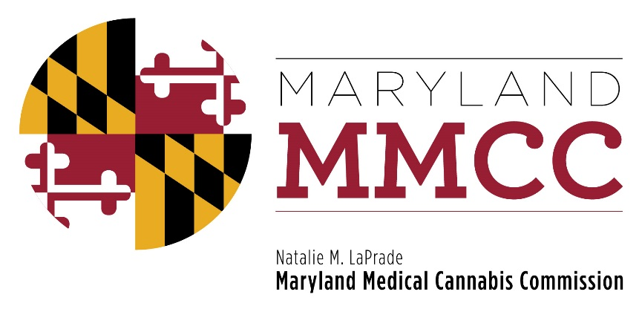
Maryland Medical Cannabis Commission
Commission Meeting
Monday, November 20, 2017
3:00 pm
Conducted Via Conference Call
AGENDA

- Call to Order and Welcome:
Commissioner Brian Lopez, Chairman

- Approval of the Minutes: October 23, 2017 Meeting Minutes
- Committee Reports:
Final Review Subcommittee Report
- Vote on Dispensary Licenses
- Vote on Independent Testing Laboratory Registration
- Next Commission Meeting: December 14, 2017
- New Business
- Adjournment

