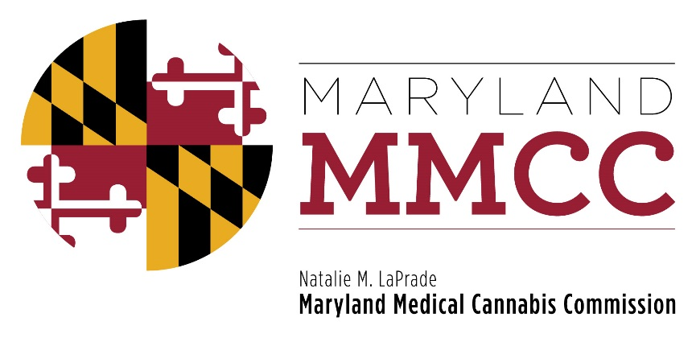
Maryland Medical Cannabis Commission
Committee Meeting
Thursday, December 14, 2017
2:00 pm
Department of Legislative Services Building
Joint Hearing Room, 1st Floor
90 State Circle, Annapolis, MD 21401

AGENDA

- Call to Order and Welcome
Commissioner Brian Lopez, Chairman

- Chairman’s Report: Commissioner Lopez

- Approval of the November 20, 2017 Meeting Minutes

- Committee Reports

- Education & Outreach Committee
- Finance & Budget Committee
- Research Committee
- Compliance Committee
- Minority Subcommittee
- Final Review Subcommittee
- Dispensary License Actions
- Transfer Requests
- Public Comments: Limited to 3 Minutes

- Closed Session to Receive Legal Counsel

- Next Full Commission Meeting

- Adjournment

