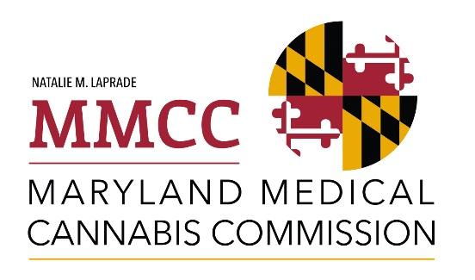

Registration is Open for Medical Cannabis Educational and Business Development Training Programs

The training programs are designed to provide instruction to small, minority, and women business owners and entrepreneurs seeking to become licensed in the medical cannabis industry but all interested persons are welcome. For more information or to register for classes, please visit the websites listed below for free class offerings as they become available.

1) UMED Pharmaceuticals, in partnership with the University of Maryland Eastern Shore (UMES) School of Pharmacy and Health Professions and Cannabis Career Institute
https://umedpharmaceuticals.net/
In-Person Classes Begin: January 19 at 10 am – 7 pm – Application, Barriers & Resources
January 20 at 10 am – 7 pm – Legal, Maryland & Federal Law
Location: BWI Hyatt Place
940 International Drive
Linthicum Heights, MD 21090
Online Classes Begin: January 22

2) Grand Journey Solutions, LLC
https://www.grandjourneysolutions.com/what-s-new
Class Schedule - pending

3) Uplift Maryland
https://www.upliftmaryland.co/mmccgrant
Introductory Meet & Greet
January 31 at 7 pm – 9 pm
Location: The Hotel at University of Maryland, College Park
The Lobby Bar
7777 Baltimore Avenue
College Park, MD 20740
Learn about Uplift Maryland’s upcoming medical cannabis educational and business development training programs. Note: Parking validation with purchase from The Lobby Bar (or any other restaurant on the property).

In-Person Classes:
February 2 at 10 am – 1 pm – Overview of Medical Cannabis Licensing Process
February 9 at 9 am – 4 pm – Business Plan Creation & Operational Development
March 2 at 9 am – 4 pm – Business Operations and Management
March 9 – 9 am – 4 pm – Marketing
March 13 – 7 pm – 9 pm – Medical Cannabis Industry Networking (Industry Panel)
March 30 – 9 am – 4 pm – Financing, Banking, Accounting, and Taxes

Location of all in-person classes: Prince George’s County - 1st Floor Conference Room
1801 McCormick Drive #140
Largo, MD 20774

Online Class:
Medical Cannabis Industry Best Practices (date of posting - pending)

