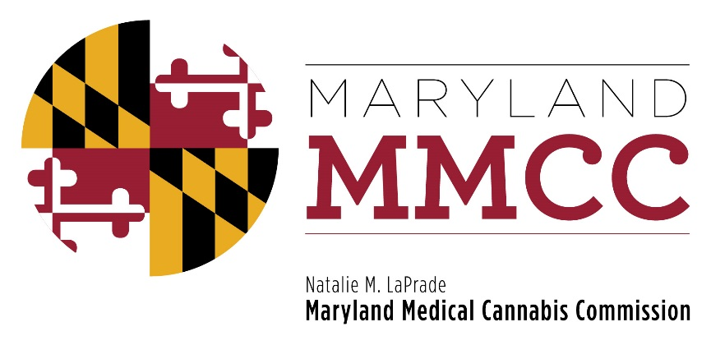
Maryland Medical Cannabis Commission
Committee Meeting
Wednesday, November 20, 2018
4:30 pm
Conducted Via Conference Call

AGENDA

- Call to Order and Welcome
- Overview: Grants – Will Tilburg, Director of Policy & Government Affairs
- Commission Vote
- Next Full Commission Meeting – December 6, 2018, Joint Hearing Room, Annapolis, Maryland, 2:00 pm
- New Business
- Adjournment

