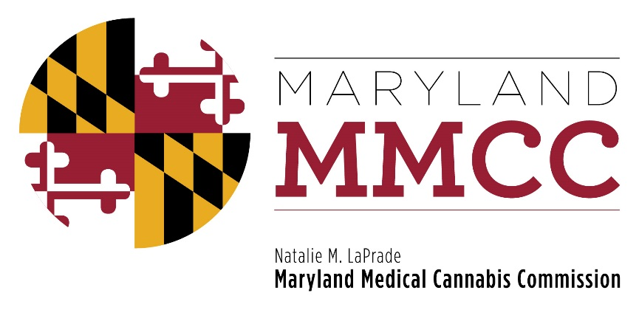
Maryland Medical Cannabis Commission
Committee Meeting
Thursday, April 16, 2018: 10:00 am
Maryland Health Care Commission
4160 Patterson Avenue, First Floor Conference Room
Baltimore, MD 21215

MINUTES

Commissioners Present Commissioners Absent
Brian Lopez, Chairman James Pyles
Charles LoDico
Barry Pope (by phone)
Tiffany Randolph
Charles Smith

MMCC Staff Present
Joy A Strand, MHA, Executive Director
Lori Dodson, Deputy Director
Christi Megna, Director of Legislative Affairs
Heather Nelson, Assistant Attorney General
Will Tilburg, Director of Policy and Government Relations
Mary-jo Mather, Director of Administration

Call to Order and Welcome
Chairman Smith called the meeting to order at 10:03 pm. A quorum was achieved.

Approval of the February 22, 2018 Meeting Minutes
After the appropriate motions were offered, the March 12, 2018 meeting minutes were approved unanimously.

Public Comment
Chairman Smith offered those attending who wished to offer comment to come forward. Wendy Bronfein of Curio offered comments on edibles. Bryan Sanderoff, Pharmacist, offered comment on a clinical director requirement in Dispensaries, as did Dr. Leslie Apgar on behalf of Greenhouse Wellness. Gina Dubbe commented on the Dispensary patient demographics. Dr. Deb Kimless, on behalf of ForwardGro, provided information about pain management and routes of administration for chronic pain relief. Gail Rand, the CFO of ForwardGro, and a patient advocate, encouraged the Commission to authorize edibles. Gary Nusinov of Temescal Wellness stated that it was the original legislative intent that edibles be introduced, and that other states offering edibles offer excellent standards for initiating such a program. Michael Bronfein concluded by stating that edibles are a strategic issue for consideration because companies are actively performing drug research and product development using edibles. Commissioner LoDico commented that stringent quality assurance would be associated with each new product, and that offering edibles would provide patients with optimum delivery of the medicine. Gina Dubbe, Gail Rand, Bill Stripling of Steep Hill Laboratories, Mike Klein and Timothy Schnup of Advent Test Laboratories commented that edible forms will always have less variance than other forms, and that correct and careful labeling would provide successful delivery to the patient.

Additional comments were received, followed by discussion, on the topics of continuing education for medical providers, advertising, clarification as to whether CBD oil can be sourced from other entities than Maryland licensed cannabis businesses (it is not authorized), and the right of the Commission do perform the necessary inspection and enforcement to verify the products sold only derive from Maryland licensed operations.

Proposed Regulations
The Commission considered proposed regulatory changes for Medical Transport Vehicles (COMAR 10.62.01). A motion to accept the proposed new language was offered by Commissioner LoDico, and seconded by Commissioner Randolph. The Motion passed unanimously. The new proposed regulations for Independent Testing Laboratories in COMAR 10.62.16 passed after the appropriate motions were offered by Commissioners.
After discussion, new provisions on Discipline and Enforcement-Payment of Penalty were passed after appropriate motions offered by Commissioners LoDico and Randolph. A technical change in the regulations passed unanimously, which would change each instance of “physician” to “certifying provider”.

The following topics were tabled for future discussion at another Policy Committee Meeting: a requirement for a Clinical Director in Dispensaries and packaging requirements.

New Business
No new business was offered.

Next Commission Meeting
The next Policy Committee meeting will be held in May, and will be announced on the Commission’s website.

Adjournment
Chairman Smith asked for a motion to adjourn, which was offered by Commissioner LoDico, and seconded by Commissioner Randolph. The meeting adjourned at 1:05 pm.

