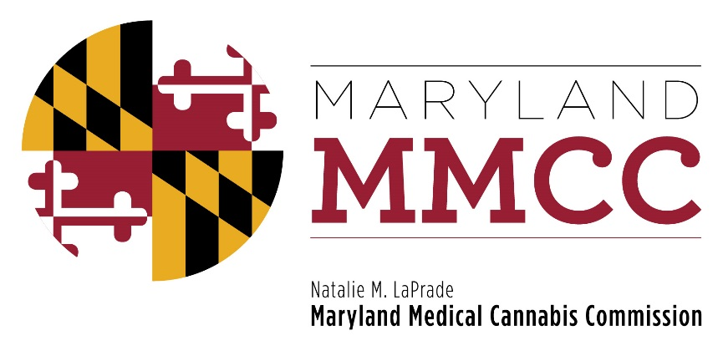
Policy Committee Meeting
Thursday, May 24, 2018: 12:30 pm
Harford County Council Chambers
212 S. Bond Street-1st Floor
Bel Air, MD 21014
AGENDA

- Call to Order and Welcome
Charlie Smith, Policy Committee Chairman

- Approval of the April 16, 2018 Meeting Minutes
- Policy Discussion: ITL Transport of Medical Cannabis
- Policy Discussion: Summary Suspension
- Policy Discussion: Use of Grant dollars for Clinical/Patient Outcome Research

- Policy Discussion: Reciprocity and Information Requests from Ohio and Washington, D.C.

- Policy Discussion: Advertising: COMAR 10.62.36
- Presentation by Will Tilburg, Director of Policy & Government Relations
- Public Comment
- Discussion
- Policy Discussion: Change of Ownership of License - COMAR 10.62.06.08. 1-/62/19. 1-/62/25
- Presentation by Will Tilburg, Director of Policy & Government Relations
- Public Comment
- Discussion

- New Business

- Adjournment

