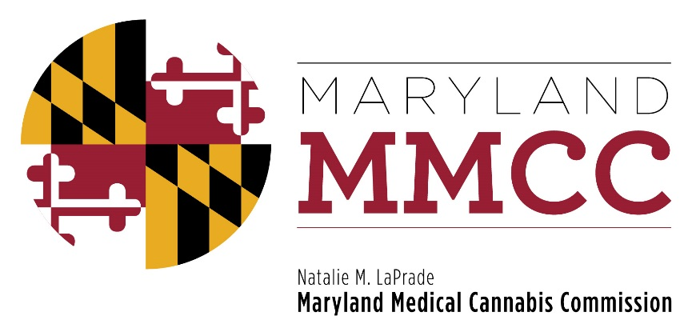
Maryland Medical Cannabis Commission
Commission Meeting
Monday, October 23, 2017
1:00 pm
Department of Legislative Services Building
Joint Hearing Room, 1st Floor
90 State Circle
Annapolis, Maryland 21401
AGENDA

- Call to Order and Welcome:
Commissioner Brian Lopez, Chairman

- Approval of the Minutes: October 3, 2017 Meeting
- Executive Director’s Report: Patrick Jameson
- Committee Reports:
Policy Committee: Commissioner Charles Smith
Research Committee: Commissioner Charles LoDico
Introduction and Presentation: Dr. Ryan Vandrey
Education and Outreach Committee: Commissioner Abdeshahian
- Next Commission Meeting
- New Business
- Adjournment

