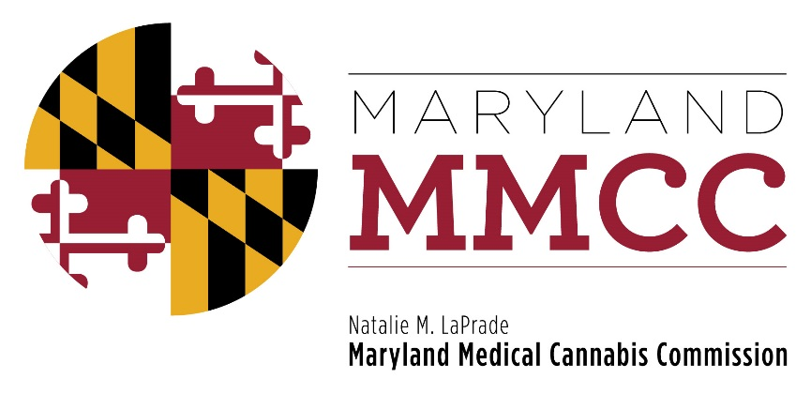
Maryland Medical Cannabis Commission
Committee Meeting
Thursday, October 5, 2017
1:00 pm
Department of Legislative Services Building
Joint Hearing Room, 1st Floor
90 State Circle
Annapolis, Maryland 21401
AGENDA

- Call to Order and Welcome:
Commissioner Charles Smith, Policy Committee Chairman

- Approval of the Minutes: September 7, 2017 Meeting
- Public Comments
- Policy Discussion:
- Out-of-state patients;
- Definitions of standards for individuals and entities for registration and licensing;
- Retention sample storage and stability testing​;
- Disposal of green waste; and
- Revocation of licenses and registrations.​
- Next Policy Committee Meeting
- New Business
- Adjournment

