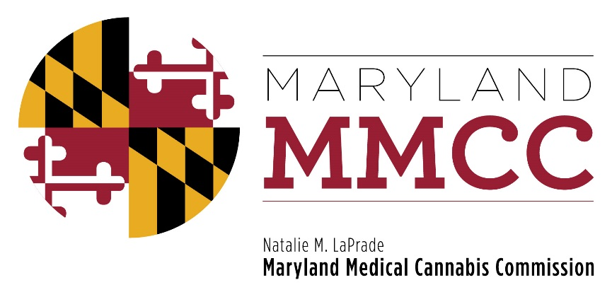
Maryland Medical Cannabis Commission
Policy Committee Meeting
Monday, October 23, 2017
11:00 am
Department of Legislative Services Building
Joint Hearing Room, 1st Floor
90 State Circle
Annapolis, Maryland 21401
AGENDA

- Call to Order and Welcome:
Commissioner Charles Smith, Policy Committee Chairman

- Approval of the Minutes: October 5, 2017 Meeting
- Policy Discussion: Potential Changes in the Regulations
- Next Policy Committee Meeting
- New Business
- Adjournment

