The Natalie M. Laprade MarylaND Medical Cannabis Commission’s (MMCC) technical Authority for medical cannabis testinG
FINAL DRAFT Revision 1
January 19, 2018

The MMCC has provided this report to define contaminants and corresponding action limits associated with those contaminants in medical cannabis. This information is intended for the independent testing laboratories registered by the MMCC.

AUTHOR:
LORI DODSON, MS, MT(ASCP)
DEPUTY DIRECTOR/DIRECTOR OF LABORATORY COMPLIANCE
NATALIE M. LAPRADE MARYLAND MEDICAL CANNABIS COMMISSION
STATE OF MARYLAND
MARYLAND DEPARTENT OF HEALTH

Acknowledgments:
The MMCC would like to thank the following individuals and organizations for their valuable contributions to this document through their work on the development of medical cannabis testing in Maryland:
Tom Phillips, MRSC, Fellow AOACI
Program Manager/State Chemist
State Chemist Section
Maryland Department of Agriculture

Prince Kassim, Ph.D.
Deputy Director for Scientific Programs
Division of Environmental Sciences
DHMH-Laboratories Administration

Monica Saunders
Quality Assurance Office
Division of Environmental Sciences
DHMH-Laboratories Administration

Eric E. Sterling, Esq.
Policy Committee Chair and Executive Committee
Maryland Medical Cannabis Commission

Shannon Moore
Executive Committee, Policy Committee and Enforcement Committee
Maryland Medical Cannabis Commission

Cristina Gouin-Paul
Policy Committee
Maryland Medical Cannabis Commission

William C. Charles, Pharm.D.
Policy Committee
Maryland Medical Cannabis Commission

Table of Contents
Introduction 1
Sampling 2
Collection Procedure for Laboratory Samples 3
Pesticides 4
Residual Solvents 5
Microbiological Impurities 6
Heavy Metals 7
Stability Testing 8
Appendix A-Medical Cannabis Testing Requirements 9
Appendix B-Definitions 10
References 1

Introduction
Analytical testing of medical cannabis for safety and potency is increasingly recognized as a critical and necessary component of the industry for several reasons (Freeman et al. 2016):
- Laboratory testing minimizes the risk of pesticides, microbes, heavy metals, toxins, and residual solvents from being consumed by an immunocompromised population;
- Quantification of cannabinoid profiles and potency becomes available for the consumer and aids in determining appropriate dosing for individual use; and
- Laboratory testing provides a sense of public safety and product quality for the medical cannabis tested.
The Maryland Medical Cannabis Commission (MMCC), with the help of a scientific work group, has established this guidance to serve as a reference for the Independent Testing Laboratories (ITL) to follow when analyzing medical cannabis. Medical cannabis safety and potency is to be analyzed based on the most current version of the cannabis inflorescence monograph published by the American Herbal Pharmacopeia (AHP), or a scientifically valid methodology that is equal or superior to that of the AHP monograph. The Code of Maryland Regulations (COMAR) 10.62.15.05A and 10.62.23.03A(1) list the compounds required for potency testing of medical cannabis. This guidance provides the lists of contaminants and the associated tolerances that the ITL is required to report as stated in COMAR 10.62.15.05B and 10.62.23.03A(2). The tolerances were established following a review of available literature in the cannabis industry as well as references from the International Conference for Harmonisation (ICH) Guideline Q3C on Impurities and the ICH Guideline Q3D on Elemental Impurities Guidance for Industry.
The four categories of contaminants identified in the Code of Maryland Regulations (COMAR) 10.62.15.05B and 10.62.23.03A(2) include:
- Pesticides;
- Residual Solvents;
- Microbiological Impurities; and
- Heavy Metals.
In an effective testing program, standardized sampling procedures are an integral component to quality laboratory testing. The data generated from all analytical methods must be consistently reliable and legally defensible. To achieve this, method precision and accuracy measurements should be performed during the sample testing process. This guidance will provide some best practices for the sample collection by the ITL.
All sampling and analysis described in this guidance shall be conducted by an independent testing laboratory registered with MMCC and in good standing with a third-party accrediting body accredited to International Organization for Standardization (ISO) 17025.
The MMCC is committed to evidence-based decision making when implementing technical guidance for the registered ITL. As research into cannabis use and safety advances, this report will be revised and updated to reflect the state of science as it pertains to the medical cannabis industry.

Sampling
The objective of a sampling procedure is to ensure the proper collection, clear labeling, proper preservation, careful transportation, and storage of samples by trained personnel for laboratory analyses. Collection of the sample is critical as it must be truly representative of the material being analyzed or the results will not be meaningful. Independent testing laboratories (ITL) are required to develop a statistically valid sampling method and collect a representative sample from each batch or lot of final product that is adequate to perform the required testing (COMAR 10.62.15.04B(1). The amount of sample required for cannabinoid or contaminant testing may vary due to sample matrix, analytical method, and laboratory-specific procedures, but a minimum sample volume of 0.5% of the batch mass of usable cannabis is required by MMCC in order to achieve a representative sample for analysis. For concentrates, extracts, and medical cannabis infused product, the sample volume will be determined by each ITL. In all cases, the amount of sample collected by the laboratory should be large enough and sufficiently homogenized to provide a representative sample of the batch but not in excess to raise issues with possible diversion or waste disposal.
Medical Cannabis sampling procedures play an important role in identifying and/or confirming the integrity of a sample, as well as the completeness of request and chain of custody forms.
To reliably provide the laboratory with a representative sample, standard sampling methods with descriptive steps must be applied with quality and consistency. All sampling must be consistently performed using accepted methodologies. It is the responsibility of the ITL to define a standard operating procedure that minimizes both imprecision and bias, and lists chronological steps that ensure a consistent and repeatable method.
The following are sampling guidelines the ITL shall use when developing a sampling protocol:
- The use of appropriate sampling equipment to avoid contamination;
- The documentation of observations and procedures used during sample collection;
- The use of an aseptic collection technique is required for antimicrobial testing;
- The importance of personal hygiene and use of person protective equipment; and
- The method used by personnel to consistently obtain samples throughout the batch.
- Additional parameters affecting sample preparation, documentation, and transport may include:
  - Accepted test sample types;
  - Minimum test sample size;
  - Test sample labeling;
  - Transport and storage conditions; and
  - The documentation of sample chain of custody.
An example collection procedure is included as a baseline reference (USP 36 2014). For detailed information regarding sample collection, please refer to “Good Samples: Guidance on Obtaining Defensible Samples” (Thiex 2015), or “Sampling Cannabis for Analytical Purposes (Sexton 2013).
(See Appendix A for information regarding required testing for each sample matrix).

EXAMPLE COLLECTION PROCEDURE FOR LABORATORY SAMPLES

Equipment:

Disposable Gloves
Calibrated Scale
Appropriate Sample Collection Vessel
70% Ethanol or Bleach Wipes

Procedure:

- Put on disposable gloves to mitigate the risk for contamination of the sample during the collection process.
- Ensure the work surface and scale are clean and decontaminated.
- Label a collection vessel with the strain name, the appropriate METRC identifier, and the batch or lot mass.
Do not sample if pertinent information is not available.
- Retrieve the container you will be collecting the sample from and wipe off the lid of the container.
- For usable cannabis: Withdraw samples from the upper, middle and lower sections of each container. With the upper section sample being taken from a depth of not less than 10 centimeters. In circumstances where there are 1-10 containers in a batch, collect a sample from all containers. Record the time the sample was collected, any inconsistencies with the sampling plan, or other remarks that might be relevant to data analysis or quality assurance.

For concentrates, extracts, and products (Solid and Semi Solid): Each sample increment should be taken from a randomly chosen position in the lot. A sample increment should be taken from each container if possible.

For concentrates, extracts, and products (Liquid): The sample should be chosen from a bulk container, ensure homogenization prior to product sampling by mixing the container thoroughly.

NOTE: The minimum sample volume to be collected from each batch of usable cannabis is 0.5% of the batch mass. The ITL must collect equal weights from each domain (upper, middle, and lower sections of the batch container) until the target sample weight is achieved.
If this does not supply sufficient mass for required analysis, the mass of the sample increments can be increased or decreased as long as they are equivalent to each other.

6) Place the sample in the appropriate collection vessel, seal and place to the side.
7) Return bulk product container to its appropriate place.
8) Wipe down the scale and work surface using either a 70% ethanol solution or bleach wipes.
9) Dispose of gloves.
10) Document the appropriate chain of custody information in METRC.

*The following sample collection procedure is based U.S. Pharmacopeia Convention Chemical Tests / 561 Articles of Botanical Origin. 2014 July.

PESTICIDES
COMAR 10.62.11.03G states pesticide applicators and applications shall follow state and federal pesticide requirements for any pesticide applied. MMCC’s current list of pesticide targets are documented in Table 1. The MMCC created the current list of pesticide targets by initially comparing lists from other states performing pesticide screens with the compounds named in the American Herbal Pharmacopoeia as commonly used in cannabis cultivation. Please note these compounds will be continually evaluated and updated based on available scientific and industry information. Action levels will be developed based on limits of quantitation (LOQ) achievable by the ITL. Cannabis samples with pesticide active ingredients detected above the action level listed below fail and the product must be destroyed.
Table 1: List of Target Pesticides and Plant Growth Regulators in Parts Per Million (PPM)
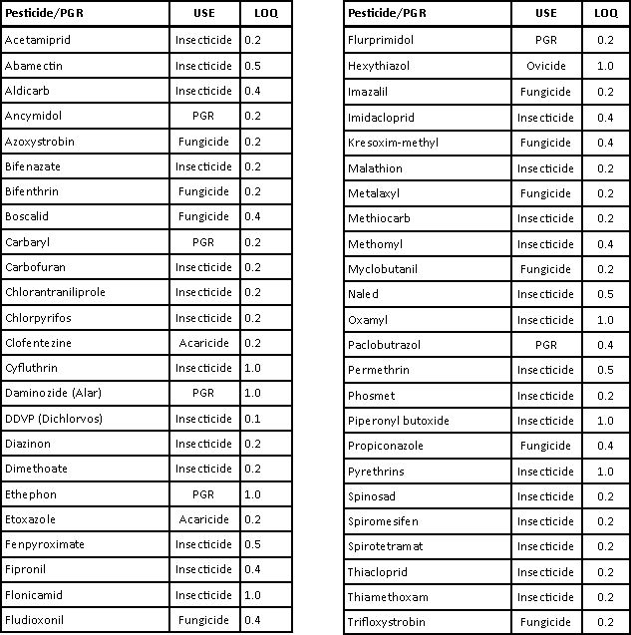

Residual Solvents
Some producers of cannabis products use solvents to extract and/or concentrate the active ingredients from cannabis. The MMCC has adopted a list of target residual solvents based on common extraction and concentration techniques in the industry. Concentration limits are based on the “International Conference for Harmonisation (ICH) Guideline Q3C (R5) on Impurities: Guidelines for residual solvents”. The concentration limits listed in ICH Q3C are based on the toxicity of the individual solvent and on the magnitude of exposure to occur from consuming 10 grams of the pharmaceutical. It is unlikely that a medical cannabis user would consume >10 grams of cannabis extract or concentrate in a single day.
Note: No health-based solvent residual limits have been established specifically for cannabis extract or concentrate products. We are uncertain whether the selected action levels for solvents in cannabis products sufficiently protect persons who smoke cannabis. However, the ICH Q3C does assume 100% absorption by any exposure route.
Table 2: Concentration Limits for Residual Solvents in Parts Per Million (PPM)
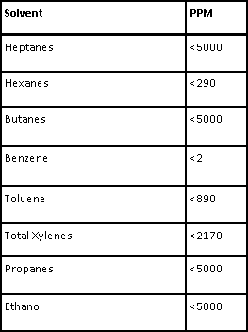

Microbiological Impurities
The presence of microbes is common in all natural products. It is important to distinguish between organisms ubiquitous in nature and those that are known pathogens. “Indicator tests” don’t directly test for pathogens, but serve as quality tests or indications that follow-up pathogen testing should be performed (Holmes et al. 2015). Additionally, microbial and fungal limits are not typically reported as “pass/fail”, the MMCC has established acceptable limits of detection based on the literature available. The MMCC requires microbiological impurities to be tested according to COMAR 10.62.15.05B(3) and COMAR 10.62.23.03A(2)(c). The criteria for acceptability in Table 3 (below) lists the microbiological impurities and the detection limits associated with each organism to be tested.
Water activity (Aw) is a measure of the available water that can be utilized for microbiological growth. Aw ranges from 0 to 1 with microbial growth unlikely below Aw 0.6. Most cannabis is dried and cured to a final water activity level of Aw 0.3-0.6, most pathogens cannot grow below Aw 0.9 (Holmes et al. 2015). Water activity, or the moisture of the cannabis flower in units, measured below Aw 0.65 will safeguard cannabis products against microbial growth during storage and before sale.

Table 3: Microbiological Impurities and Accepted Detection Limits in Colony Forming Units (CFU/g) and Parts Per Billion (PPB)
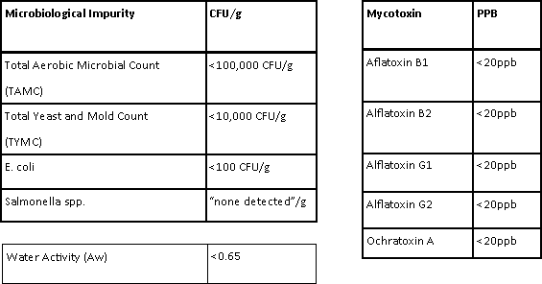

Heavy Metals
Elemental impurities do not provide any therapeutic benefit to the medical cannabis patient. Because of their high degree of toxicity, arsenic, cadmium, chromium, lead, and mercury rank among the priority metals that are of public health significance (Tchounwou P et al. 2012). The MMCC requires an ITL to test for heavy metal presence in medical cannabis (COMAR 10.62.15.05B(1)). Table 4 lists the eight heavy metals required in contaminant testing and their associated concentration limits based on a 5 gram/day consumption of medical cannabis.
Note: The permitted daily exposure (PDE) for heavy metals is based on the Q3D Elemental Impurities Guidance for Industry.

Table 4: Heavy Metals and Associated Concentration Limits in Parts Per Million (PPM)
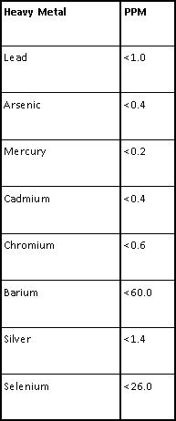

Stability Testing
COMAR (10.62.15.07 and 10.62.23.05) states that stability testing is to be performed at 6-month and 1 year intervals. The purpose of stability testing is to provide evidence on how the quality of a drug substance varies with time under the influence of a variety of environmental factors (ICH 2003).
The ITL must have policies and procedures established for the collection of stability and retention samples and the analysis of stability testing samples. The samples must be stored in a secure, climate-controlled facility, mirroring packaging and temperature conditions of a medical cannabis dispensary (25̊ Celsius (C) +/- 2̊ C and 60% Relative Humidity (RH) +/- 5% RH).
The stability testing required at 6 months and 1 year intervals will include:
- Cannabinoid content;
- Microbiological impurities; and
- Water activity.
Findings of the stability studies will be reported to MMCC through the METRC tracking system to ensure medical cannabis purity and potency are maintained throughout the storage process without significant change. Significant change for medical cannabis is defined as failure to meet the tolerances listed in this technical guidance for purity.
The design of the laboratory’s stability studies must include the following factors as standard requirements (ICH 2003):
- Samples from at least 3 batches of medical cannabis stored in a secure, climate controlled environment
- Samples must be stored undisturbed at the designated storage temperature for the appropriate time interval
- Stability samples must reflect a representative sample of the entire batch
- Potency and purity analysis must be performed in duplicate, and the physical condition/appearance of the contents must be observed and reported
- Resulting the stability studies data must include:
- METRC identification and batch weight
- Conditions of storage (including container type)
- Analysis from original sampling, 6 month, and 1 year sampling
- Name and type of product
- Name and address of the independent testing laboratory

APPENDIX A- Medical Cannabis Testing Requirements
 | Usable Cannabis | Medical Cannabis Concentrate  (non-solvent) | Medical Cannabis Concentrate  (solvent based) made with CO2 Extractor | Medical Cannabis Concentrate (solvent based) | Medical Cannabis-Infused Product | Dilutions of Medical Cannabis Product
Moisture Content | √
Potency Analysis | √ | √ | √ | √ | √ | √
Terpene Analysis | √ | √ | √ | √ | √ | √
Foreign Matter Inspection | √
Microbial Screen | √ | √ | √ | √ | √
Mycotoxin Screen | √
Water Activity | √
Heavy Metal Screen | √
Residual Solvent Test |  |  |  | √
Pesticide Residue Analysis | √ | √ | √ | √ | √

APPENDIX B-DEFINITIONS
Batch- Means not more than 10 pounds(lbs) of plants of the same variety of medical cannabis that have been:
- Grown, harvested, and processed together; and
- Exposed to substantially similar conditions throughout cultivation and processing.
Chain of Custody- The chronological documentation showing the collection, custody, control, transfer, analysis, and disposition of a sample.
Commission- The Natalie M. LaPrade Medical Cannabis Commission.
CFU/g- Colony forming units per gram. Refers to a measure of the amount of living bacteria per given amount (1 gram) of a sample.
Independent Testing Laboratory- A facility, entity, or site that offers or performs tests of medical cannabis and products containing medical cannabis that is:
(a) Accredited as operating to ISO standard 17025 by an accreditation body that is:
(i) Operating in accordance with the International Organization for Standardization (ISO) standard ISO/IEC 17011; and
(ii) A signatory to the International Laboratory Accreditation Cooperation (ILAC) Mutual Recognition Arrangement (MRA);
(b) Independent from all other persons involved in the Maryland cannabis industry; and
(c) Registered with the Commission.
Limit of Quantification (LOQ)- The lowest concentration at which the analyte can not only be reliably detected but at which some predefined goals for bias and imprecision are met.
Lot- medical cannabis finished product that is uniform, and that is manufactured, packaged, or labeled together during a specified time period according to a single lot record.
METRC- Franwell Marijuana Enforcement Tracking Regulation and Compliance system.
Medical Cannabis- Any product containing usable cannabis or medical cannabis finished product.
Medical Cannabis Concentrate- A product derived from medical cannabis that is kief, hashish, bubble hash, oil, wax, or other product, derived from cannabis or that includes cannabinoids extracted from the plant by any means.
Medical Cannabis-Infused Product-
- Any oil, wax, ointment, salve, tincture, capsule, suppository, dermal patch, cartridge or other product containing medical cannabis concentrate or usable cannabis.
- Does not include a food.
Representative Sample- A sample obtained according to a sampling procedure designed to ensure that the different parts of a batch or lot or the different properties of a batch or lot are proportionally represented.
Sample- An amount of medical cannabis collected by laboratory personnel from a licensee and provided to an independent testing laboratory for testing.
Solvent- A substance that can dissolve another substance, or in which another substance is dissolved, forming a solution.
Target Analyte- A chemical the lab must test for to see if it is present in medical cannabis.
Usable Cannabis-
- The dried leaves and flowers of the cannabis plant.
- Does not include seedlings, seeds, stems, stalks or roots of the plant.
Water Activity- The partial vapor pressure of water in a substance divided by the standard state partial vapor pressure of water.

References
Freeman K, McHenry M, Cats-Baril W, Grace T. Cannabis Testing for Public Safety-Best Practices for Vermont Analytical Laboratories. PhytoScience Institute, 2016 January.
Upton R, Craker L, ElSohly M, Romm A, Russo E, Sexton M. Cannabis Inflorescence: Standards of Identity, Analysis, and Quality Control. American Herbal Pharmacopoeia. Revision 2014.
Thiex N, Ramsey C, Bhikha R, Cook J, Crawford A, Danielson D, Graves Q, Hirt W, Hoffman G, Andujar L, McLaughlin M, McManus K, McMullen S, Montalbano A, Novotny L, Salfinger Y, Schroder B, Scott T, Stephens R. Guidance on obtaining defensible samples. GOODSamples: Sampling and Sample Handling Working Group. 2015 October.
Farrer DG. Technical Report: Oregon Health Authority’s process to decide which types of contaminants to test for in cannabis. Oregon Health Authority. 2015 December.
Osterbauer N, Krepps S, Sackett J, Holladay C, Wendt E, Wells D, Price S, Kristof J. Protocol for Collecting Samples of Usable Marijuana. ORELAP-SOP-001 Rev.3.0. 2016 December.
Sexton M, Ziskind J. Sampling Cannabis for Analytical Purposes. BOTEC Analysis Corp. 2013 November.
Voelker R, Holmes M. Pesticide use on cannabis. Cannabis Safety Institute, 2015 June.
Holmes M, Vyas J, Steinbach W, McPartland J. Microbiological Safety Testing of Cannabis. Cannabis Safety Institute, 2015 May.
International Council for Harmonisation. Guideline Q3C (R5) on Impurities: Guidelines for residual solvents. 2015 September.
International Council for Harmonisation. Guideline Q3D Elemental Impurities: Guidance for Industry. 2015 September.
Unger P, Brauinger R, Hudalla C, Holmes M, Sherman B. Standards for Cannabis Testing Laboratories. Cannabis Safety Institute. 2014 December.
Raber J, Elzings S, Kaplan C. Understanding dabs: contamination concerns of cannabis concentrates and cannabinoid transfer during the act of dabbing. The Journal of Toxicological Sciences. Vol. 40, No. 6, 797-803, 2015 September.
Aldous K, Applen J, Fan Z, Fox M, Kassner S, Latshaw M, Nascarella M, Starr G, Swantek S, Verbrugge D. Guidance for State Medical Cannabis Testing Programs. Association of Public Health Laboratories. 2016 May.
International Council for Harmonisation. Guidance for Industry: Q1A(R2) Stability Testing of New Drug Substances and Products. 2003 November.
Tchounwou P, Yedjou C, Patlolla A, Sutton D. Heavy Metals Toxicity and the Environment. Molecular, Clinical and Environmental Toxicology. Volume 101 of EXS, 133-164. 2012 April.
U.S. Pharmacopeia Convention (USP). Chemical Tests / 561 Articles of Botanical Origin. 2014 July.

