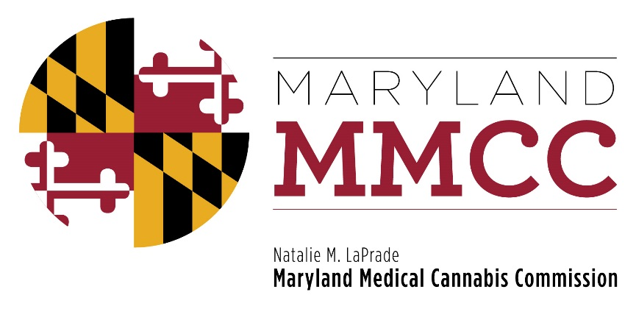
Maryland Medical Cannabis Commission

AGENDA
Wednesday, July 5, 2017
Maryland Health Care Commission
4160 Patterson Avenue, Room 100
Baltimore, Maryland 21215

AGENDA

- Call to Order

- Approval of Minutes: June 26, 2017 Meeting

- Executive Director’s Update

- Committee Reports:
Final Review Subcommittee: Buddy Robshaw

- New Business

- Adjournment

