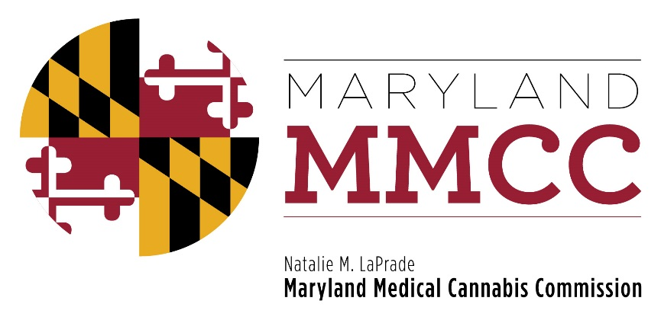
Maryland Medical Cannabis Commission
Committee Meeting
Thursday, February 22, 2018
2:00 pm
Maryland Health Care Commission
4160 Patterson Avenue, First Floor Conference Room
Baltimore, MD 21215
AGENDA

- Call to Order and Welcome
Commissioner Brian Lopez, Chairman

- Approval of the January 25, 2018 Meeting Minutes

- Executive Director’s Report: Joy A. Strand, MHA

- Legislative Affairs Update: Christi Megna, Esquire

- Subcommittee Reports:
1)Final Review Subcommittee Report
2)Minority Subcommittee Report
- Dispensary License Voting

- New Business

- Next Full Commission Meeting

- Adjournment

