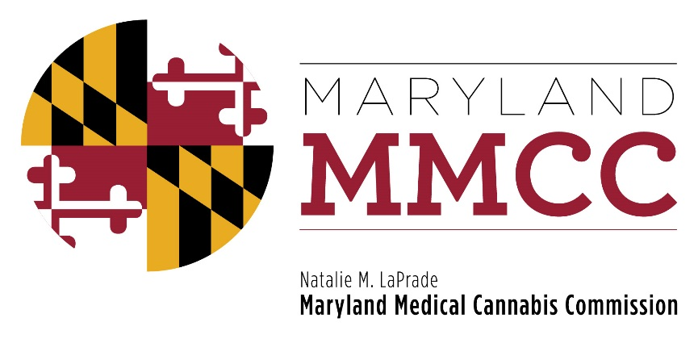
Maryland Medical Cannabis Commission
Committee Meeting
Thursday, April 10, 2018: 2:00 pm
Maryland Health Care Commission
4160 Patterson Avenue, First Floor Conference Room
Baltimore, MD 21215

MINUTES

Commissioners Present Commissioners Absent
Brian Lopez, Chairman Ehsan Abdeshahian
Jeffrey Gahler Alvin Davis
John Gontrum Jean Marshall
Charles LoDico Nancy Rosen-Cohen
Barry Pope
James Pyles
Tiffany Randolph
Rachel Rhodes (via telephone)
Charles Smith
Sandy Washington
Scott Welsh

MMCC Staff Present
Joy A Strand, MHA, Executive Director
Lori Dodson, Deputy Director
David Kloos, Director of Enforcement and Compliance
Heather Nelson, Assistant Attorney General
Will Tilburg, Director of Policy and Government Relations
Mary-jo Mather, Director of Administration

Call to Order and Welcome
Chairman Lopez called the meeting to order at 2:03 pm. A quorum was achieved.

Approval of the February 22, 2018 Meeting Minutes
After the appropriate motions were offered, the February 22, 2018 meeting minutes were approved unanimously.

Reports
Chairman Lopez, Executive Director Strand, and Mr. Tilburg offered reports. Ms. Strand noted recent Bulletins posted on the web site pertaining to quarterly reports and obtaining cannabis only from licensees. She reported the most recent Patient, Provider and Caregiver statistics. Mr. Tilburg provided information on new provisions of House Bill 2, as well as the 24 action items which must be performed by the Commission in the coming months and years. He noted that bill awaits the Governor’s signature. Mr. Tilburg summarized measures which did not pass during the Session.

Proposed Regulations
The Commission considered proposed regulatory changes approved by the Policy Committee at its March 12 meeting. Following consideration, a motion, second, and approval the Commission adopted proposed regulations pertaining to the Qualifying Patient Definition; a requirement that each licensed Dispensary must have a Clinical Director; Requirements for Heavy Metals and pesticide residue testing for processed products which are not inhaled; new ITL fees; cannabis pickups by licensees; Secure Transport Company requirements for registering agents and requiring agent cards; and a new requirement that all Patients must be issued Patient Cards. All approved regulatory changes will be posted for public comment in the Maryland Register after the necessary legal review is completed.

Subcommittee Report

Final Review Subcommittee
Chairman Smith presented the Subcommittee’s recommendation to license seven Dispensaries. The Final Review Subcommittee, by a vote of 5-0, determined that each Dispensary applicant has met the regulatory requirements, and recommended that a license to dispense medical cannabis for each of the nine entities be issued pursuant to COMAR 10.62.25.07. After the appropriate motions were offered, the full Commission voted, with one abstention, to approve licensure for seven Dispensaries: CannaMD LLC (dba ReLeaf Shop); Doctors Orders/CULTA; M2C2 LLC (dba HerbiFi); Meshow LLC (dba RISE Joppa); Our Community Wellness & Compassionate Care (dba Medleaf); Maryland Earthworks LLC (dba Dispensary Works); and Peake Releaf.

Chairman Smith presented the Subcommittee’s recommendation to license Seven Points Agro Therapeutics LLC as a Processor. The Final Review Subcommittee, by a vote of 5-0, determined that the applicant had met the regulatory requirements, and that a Processor license be issued pursuant to COMAR 10.62.19.06. After the appropriate motions were offered, the full Commission voted, with one abstention, to approve a Processor license for Seven Points Agro Therapeutics LLC.

Commissioner Lopez provided the regulatory requirements for a change in entity name. A motion was offered and appropriately seconded authorizing Maryland Earthworks to change their name to Dispensary Works, and Doctors Orders Maryland LLC to change all of their licensees to replace Doctors Orders with Culta LLC. The motions passed unanimously with no abstentions.

New Business
No new business was offered.

Next Commission Meeting
The next meeting will be held on May 24, 2018. The venue is not yet selected.

Adjournment
Chairman Lopez adjourned the meeting at 2:50 pm.

