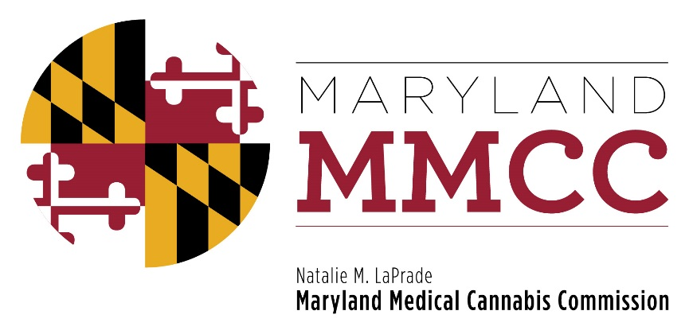
Maryland Medical Cannabis Commission
Meeting
November 28, 2016
10:00 am
Howard Building-Banneker Room
3410-3450 Court House Drive
Ellicott City, Maryland 21043

MINUTES

Commissioners Present:
Paul Davies, Chairman
Dario Broccolino
William (Chris) Charles
John Gontrum
Michael Horberg
Shannon Moore
Tina Paul
James Pyles
Harry (Buddy) Robshaw (Vice-Chairman)
Nancy Rosen-Cohen
Eric Sterling
Allison Taylor
Jon Traunfield
Jean Gilmore Marshall
Sandy Washington

Commissioners Present by Telephone:
Nancy Rosen-Cohen

Staff Present:
Patrick Jameson, Executive Director
Mary-jo Mather, Director of Administration
Vanessa Lyon, Director of Communications
Myesha McQueen, Administrative Specialist
Heather Nelson, Assistant Attorney General
David Kloos Director, Bureau of Enforcement and Compliance
Garrett Keene, Senior Investigator
Paul Quill, Senior Investigator
Mark Rodeheaver, Senior Investigator
Nicole Felder, Director of Program Analytics
Precious Wells, Administrative Specialist

CALL TO ORDER

Chairman Davies called the meeting to order at 10:04 am and welcomed the attendees. He thanked Allan H. Kittleman and the Howard County Council for allowing the Commission to use their facility again for the meeting. He asked each Commissioner to introduce themselves.
APPROVAL OF THE MINUTES

Chairman asked if Commissioners had had time to review the draft Minutes of the August 5, 2016 meeting. Chris Charles noted some small non-substantive corrections. Chairman Davies then asked for a Motion to Approve the Minutes, which was offered by Commissioner Charles, and seconded by Commissioner Pyles. The Minutes were approved unanimously, with Commissioner Charles’ changes. There were no abstentions.

EXECUTIVE DIRECTOR’S REPORT

Executive Director Jameson announced that the Commission would be voting at the meeting on the Stage One pre-approvals for Dispensaries. He noted that the entity names would not be announced on the Commission’s website until December 9th. All applicants will be notified on that date by US Mail as well as via email to the authorized contact for each applicant.

Mr. Jameson reported that there had been extensive comments about the diversity of applicants reported in the press in the last few months, and announced that, from data voluntarily supplied by the applicants themselves, that there is a great deal of diversity already in ownership and in employees. He referred the public to the statistics posted on the Commission’s website. He also reported that the final data was not yet available on financial ownership in for every applicant since many entities were still in the process of finalizing their investors. He reported that the Commission will be asking each licensed entity for their diversity plan and data on an annual basis. He reported that the Commission will be hiring a diversity consultant to study this issue.

Chairman’s Report
Chairman Davies commented that the Commission is looking forward to having the pre-approvals for Dispensaries issued. He commented that the next few weeks would be exciting and would bring years of work by the entire Commission to fruition. He introduced Commissioner Shannon Moore, who would be offering the Report of the Dispensary Evaluation Subcommittee and would discuss any concerns the Commissioners may have.

COMMITTEE REPORT:

Dispensary Evaluation Subcommittee: Reported presented by Commissioner Shannon Moore

Commissioner Moore thanked the Subcommittee for their extraordinary work. 102 applications were reviewed. Ninety-two pre-awards are being recommended. In two of the Senatorial Districts, only 1 entity was recommended for pre-approval. Ms. Moore asked for a Motion to approve the list of recommended Dispensaries for pre-approval.
Commissioner Horberg offered the Motion, which was seconded by Commissioner Taylor. A voice vote was taken. The Motion was passed, with one abstention by Commissioner Broccolino.

New Business

Chairman Davies asked if any Commissioner wanted to discuss any new business.
Commissioner Washington asked if she could ask a legal question about diversity and the process. Assistant Attorney General Nelson stated that the statutory language contained vague language about achieving diversity. Chairman Davies commented that the Commission was not awarding a business contract, but a license. Executive Director Jameson stated that a consultant would be hired to collect diversity data, like the Department of Transportation has done, using NAICS codes from analogous industries. He noted further that the cannabis industry is very unique.

CLOSED SESSION

Commissioner Washington asked that the Commission go into closed session to receive legal advice from Assistant Attorney General Nelson. Commissioner Washington offered a Motion to Close the Meeting to receive legal advice, which was appropriately seconded. The meeting went into Closed Session at 10:25 am and the open Commission meeting reconvened at 10:50 am.

ADJOURNMENT

At 10:50 am, Chair Davies asked for a Motion to Adjourn. It was offered by Commissioner Gontrum, and seconded by Commissioner Taylor. The Motion passed unanimously, and the open meeting of the Maryland Medical Cannabis Commission adjourned at 10:51 am.

