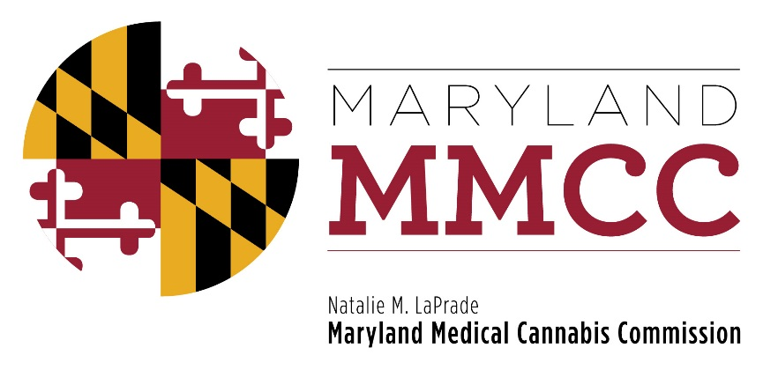
Maryland Medical Cannabis Commission
Meeting Minutes
June 26, 2017
1:00 pm
Conducted by Conference Call

Commissioners Present Via Telephone:
Dario Broccolino
Paul Davies (Chairman)
Michael Horberg
Robert Lavin
Jeanie Marshall
Tina Paul
James Pyles
Harry (Buddy) Robshaw (Vice-Chairman)
Nancy Rosen-Cohen
Eric Sterling
Jon Traunfeld
Sandy Washington

Commissioners Absent
John Gontrum

Staff Present:
Patrick Jameson, Executive Director
Mary-jo Mather, Director of Administration
Heather Nelson, Assistant Attorney General
David Kloos Director, Bureau of Enforcement and Compliance
Garrett Keene, Senior Investigator
Mark Rodeheaver, Senior Investigator
Nicole Felder, Director of Program Analytics
Lori Dodson, Director of Compliance for Independent Testing Laboratories

CALL TO ORDER
Vice Chairman Robshaw called the meeting to order at 1:02 pm and welcomed the attendees.

APPROVAL OF THE MINUTES

Vice Chairman Robshaw asked if Commissioners had time to review the draft minutes of the November 28, 2016 and May 17, 2017 meetings. He then asked for a Motion to Approve the Minutes, which was offered by Commissioner Rosen-Cohen and seconded by Commissioner Horberg. The November 28, 2016 and May 17, 2017 Minutes were approved unanimously.

VICE CHAIRMAN’S REPORT and CLOSING OF THE MEETING TO RECEIVE LEGAL ADVICE AND TO DISCUSS PENDING LITIGATION

At 1:05 pm, Vice Chairman Robshaw stated that the Commission would be closing the public meeting to receive legal advice and an update on the litigation from Assistant Attorney General Heather Nelson. Commissioner Sterling offered a Motion to Close the Meeting to receive legal advice and an update on the litigation, and Commissioner Rosen-Cohen seconded the Motion. The vote to close the meeting was unanimous. The members of the Commission moved into closed session at 1:02 pm and reconvened at 1:33 pm
Mr. Robshaw invited Commissioner Sterling to offer the report of the Final Review Subcommittee.
COMMITTEE REPORT

Final Review Subcommittee Report: Commissioner Eric Sterling

Commissioner Sterling reported that the Final Review Subcommittee had met, carefully reviewed documentation and had conferred with Commission investigators. He stated that the Maryland Medical Cannabis Commission has the authority to deny a license if it believes there is a risk of diversion, or determines that there is evidence of a lack of good moral character. Based on that authority, and the report of the Bureau of Enforcement and Compliance, the Final Review Subcommittee recommended that the suspension of MaryMed LLC’s Grower, Processor and Dispensary applications be lifted, and also voted to recommend that the Commission issue MaryMed a notice of intent to deny the licenses for a medical cannabis grower, processor and dispensary. Commissioner Sterling asked for a Motion to (1) lift the suspension, and (2) to issue a notice of intent to deny the issuance of a license to MaryMed for a grower, processor and dispensary license. Each Motion was offered, and appropriately seconded. The Commission voted unanimously to lift the suspension of MaryMed’s grower, processor and dispensary license, and then to issue an intent to deny licensure for each of these applications.

New Business

Vice Chairman Robshaw asked those attending if they had any new business to discuss. Hearing none, he asked for a Motion to Adjourn.

Adjournment

There being no further discussion, Commissioner Rosen-Cohen offered a Motion to Adjourn, which was appropriately seconded by Commissioner Washington. The Motion passed unanimously and the meeting adjourned at 1:40 pm.

