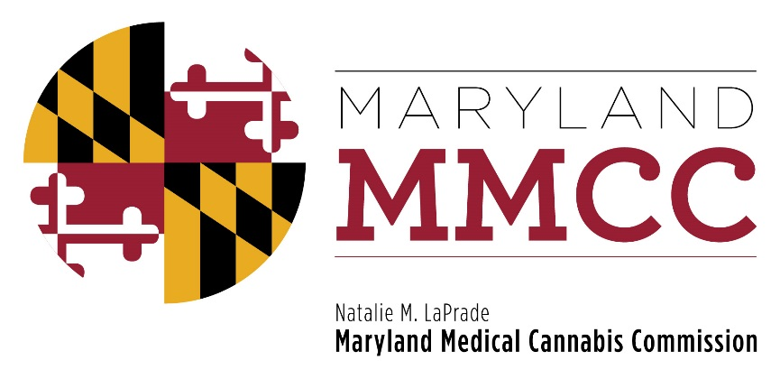
Maryland Medical Cannabis Commission
Committee Meeting
Thursday, February 22, 2018: 2:00 pm
Maryland Health Care Commission
4160 Patterson Avenue, First Floor Conference Room
Baltimore, MD 21215

MINUTES

Commissioners Present Commissioners Absent
Brian Lopez, Chairman Alvin Davis
Ehsan Abdeshahian James Pyles
Jeffrey Gahler (via telephone) Charles Simmons
John Gontrum Saundra Washington
Charles LoDico
Jean Marshall
Barry Pope (via telephone)
Tiffany Randolph
Rachel Rhodes (via telephone)
Nancy Rosen-Cohen
Charles Smith (via telephone)
Scott Welsh

MMCC Staff Present
Joy A Strand, MHA, Executive Director
Lori Dodson, Deputy Director
Director of Enforcement and Compliance
Heather Nelson, Assistant Attorney General
Christi Megna, Director of Legislative Affairs
Will Tilburg, Director of Policy and Government Relations
Mary-jo Mather, Director of Administration

Call to Order and Welcome
Chairman Lopez called the meeting to order at 2:02 pm. A quorum was achieved.

Approval of the December 14, 2017 Meeting Minutes
Chairman Lopez requested a motion to approve the previous meeting minutes. It was offered by Commissioner Rhodes, and seconded by Commissioner Randolph. The minutes were approved unanimously.

Chairman’s Report
Chairman Lopez reported that the Policy Committee and the Minority Affairs Subcommittee will be meeting in the second or third week of April. No other committees have recently met. The Policy Committee will continue to discuss the out-of-state patient issue, as well as many others, and Policy Committee Chairman Smith plans to post the issues to be discussed on the MMCC website.

Executive Director’s Report

Executive Director Strand provided updates on hiring and new staff. Jennifer White is the new Director of Communications and will begin work on February 28, 2018. Todd Liddick has been hired as the newest Senior Investigator. The Commission is currently recruiting for a Director of Finance, a Director of Program Analytics, and additional field investigators.

Ms. Strand provided the current statistics for the Patient, Caregiver and Provider Registries. As of February 22, 2018, there are 719 registered medical providers. There are 24,564 registered Patients, and 16,055 of the registered Patients are certified. There are 82 registered minor Patients, of which 55 are certified, and 80 registered hospice Patients. The number of Caregivers registered as of February 22 totals 1,222. The QA staff is currently ten business days behind on processing applications. There are 8,675 pending Patient applications awaiting final processing.
Executive Director Strand also announced the posting of two new Bulletins on the MMCC website: notice that the Commission is extending the administrative hold on Out-Of-State Patient Applications on February 16, and on February 21, a Bulletin regarding Notice, Review, and Written Approval of a Change of Ownership.
Ms. Strand reported that in the last few weeks she has established several workgroups which will give industry the opportunity for input on all aspects of the medical cannabis industry. The workgroups are in various stages of development. Currently there are plans for a technology workgroup, an advisory workgroup composed of Grower, Processor and Dispensary representatives, which will focus on how the Commission and stakeholders can collectively improve processes, regulations and services; a law enforcement workgroup, which will provide information on the interplay of medical cannabis patients and caregivers and law enforcement; a patient workgroup, and a provider workgroup which will provide insight, from a clinical point of view, from all types of medical providers currently authorized to recommend medical cannabis. Ms. Strand reported that Deputy Director Dodson, who is also the Director of Enforcement for the Independent Testing Laboratories, has already convened the Independent Testing Laboratory directors’ workgroup for two meetings, as well as a public health workgroup.
Legislative Affairs
Ms. Megna reported that there are approximately 25 bills being reviewed by the Commission of the 38 cannabis-related bills introduced this Session. The Commission provided suggested amendments for House Bill 2/Senate Bill 1. Various topics under consideration include a cap on licenses, a moratorium postponing licensing until a future date, reconstituting the composition of the Commission, adding language regarding Commissioner diversity to the current statute.

Other bills include a prohibition of medical cannabis by prisoners in certain correctional facilities; requirements for a bona fide medical cannabis patient/provider relationship and referrals; a requirement that all patients must possess medical cannabis ID cards issued by the Commission; requirements for packaging; requiring Commission approval for advertising by Growers, Processors, Dispensaries, and other parties; and prohibitions of the ownership of firearms by medical cannabis patients. Other bills concern secure transportation company requirements.

Committee Reports

Minority Subcommittee
Commissioner Randolph announced that the Subcommittee is working on a report which will be released in the near future.

Final Review Subcommittee
Mr. Lopez announced that the Commission is closely monitoring the progress of the remaining pre-approved Processors and Dispensaries. Chairman Abdeshahian presented the Subcommittee’s recommendation to license nine Dispensaries. He noted that the Investigator was available via phone for the review of the material and to answer questions. The Investigative Summary, Financial Summary, and Inspection Summary were provided by the inspector. No information was identified that would prohibit the applicant from being licensed. Notice of inspection, pre-inspection checklist, Dispensary inspection report, and the Investigative Background Checklist were provided and in good order. No additional investigative information was necessary or provided. The Final Review Subcommittee, by a vote of 5-0, determined that each Dispensary applicant has met the requirements.

Commissioner Abdeshahian stated that:
- The Final Review Subcommittee recommends that the Commission find that the following prerequisites have been satisfied for each of the nine entities being considered for licensure:
    - That the application for Medical Cannabis Dispensary License was awarded a pre-approval in December of 2016.
    - Since that time, as part of its application:
    - An audited financial statement the Dispensary and any proposed Dispensary agents was received; and payment of the stage 2 application fee specified in COMAR 10.62.35.01
  - The Bureau of Enforcement and Compliance has reported to the Final Review Subcommittee that:
    - Examination of financial statements, criminal history reports, and Stage Two application materials have revealed no evidence of any non-compliance with the regulations;
    - All inspections, including inspections of standard operating procedures and inspections of premises, have been passed and the Dispensaries’ operations conform to the specifications of the application as pre-approved;
    - The premises prepared:
      - are under the legal control of the Dispensary;
      - comply with all zoning and planning requirements; and
      - conform to the specifications of the application as pre-approved.
    - The first year's license fee as specified in COMAR 10.62.35.01 has been paid.
  - The Final Review Subcommittee therefore recommends that a license to dispense medical cannabis for each of the nine entities be issued pursuant to COMAR 10.62.25.07.

After the appropriate motions were offered, the full Commission voted unanimously to approve licensure for nine Dispensaries: Canna Cuzzos LLC (DBA Zen Leaf Waldorf),
Chesapeake Apothecary LLC, Curio Wellness Dispensary, CWS LLC (DBA Your Farmacy Dispensary), Halloway LLC (DBA Starbuds), HMS Health LLC (DBA Zenity Wellness Dispensary), OC Botanicals (DBA Hi Tide Dispensary) PalliaTech Maryland LLC (DBA Curaleaf) and Trilogy Wellness of Maryland LLC.

New Business
No new business was offered.

Adjournment
Chairman Lopez adjourned the meeting at 2:50 pm.

